Project Identification

Project: | Rental Application Website
Prepared By: | T21
Document Version: | 0.1
Published Date: | 09/30/2022

Contributors
The following individuals contributed to this document.
Name | Title
Abdelaziz Omar | Front End Development
Artem Elagin | Backend Development
Elham Veisouei | Data Manager
Lale Mulati | Testing Engineer

Distribution
This document is distributed to all the following people.
Name | Title

Referenced Documents
This document refers to the following materials
Version number | Title | Author | Date | Source / Location
0.1

Revision History

Version Number | Revision Date | Summary of Changes | Modified by
0.1 | Sep 30, 2022
[Note: It is recommended that drafts be numbered 0.1 to 0.9, and that the first approved version be numbered 1.0. Thereafter, new version numbers will depend upon changes: 1.01, 1.1, etc for minor updates, 2.0, 3.0 etc for major changes.]

TABLE OF CONTENTS
1. Business Context Diagram 3
2. REquirements Scope Statements 4
3. High Level Business Requirements (HLR) Traceability 4
4. High Level Business Requirements Sign-Off 5

- Business Context Diagram
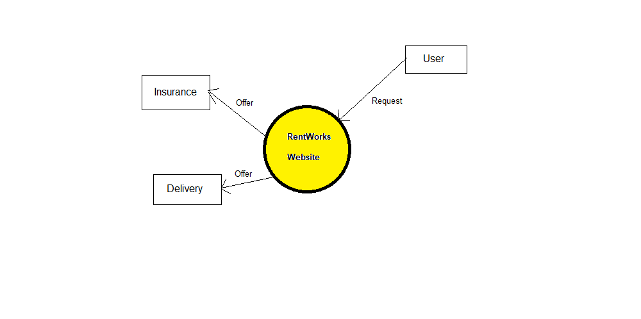

Requirement Scope Area | Description
RentWorks Website | Responsible for safe lend and rent. Provide insurance, and delivery.

External Entity | Description
User | Sign up as host(lender), or guest(renter).
Insurance | Whenever any unexpected things happen, this responsible for makeup.
Delivery | When order is completed, platform will request the delivery.

Information Flows | Description
Request | It is the command given by the user to perform any tasks.
Offer | When user wants extra service platform will offer extra service based on their request.
- Requirements Scope Statements
HLR# | Description | Priority  (H, M, L)
 | Customer support: user can sign in as a host(lender) and guest(lender) and can communicate with each other with their privacy. | H
 | Transaction: safe and international transaction must have. | H
 | Insurance: for safe trade insurance is vital both for host and guest. | H
HLR04 | Delivery: if Host is not available to delivery, platform can offer. | M
HLR05 | User page: to protect user’s privacy, platform will hide part of their personal information. | L

- High Level Business Requirements Sign-Off
The undersigned acknowledge their agreement with the contents of Version <0.1> of the High-Level Requirements document for <RentWorks>.

Following approval of this document, requirements changes will be governed by the project’s change management process, including impact analysis and appropriate reviews and approvals, under the general control of the Project Plan and according to company policy. Approved Change Request Documents, if present, will be attached to this Requirements Document as updates.

Name | Project Role and  Functional Area | Date Signed
Anjana Shah | Project Manager: Manages all the project flows.

* Note: physical signatures are not required. Email approvals are acceptable and should be appended to project documents.

